Colegio Provincial San José  
Sede Central  
Pamplona, 2020

**MULTIMODAL SELF-LEARNING WORKSHOP**

**AREA: Foreign Language**

**SUBJECT: English**

**NINTH GRADE**

**TEACHER: Ms. Sandra Lucia Castellanos Bautista**

**UNIT 1: Your world**

**LESSON 1: TO BE PAST AND FUTURE TENSES**

* **DBA:** Exchanges information about academic and general interest topics in a conversation.
* **COMPETENCE**: Linguistics**,** Pragmatics and socio-linguistics.
* **TIME OF STUDY:** 4 hours
* **GENERAL INSTRUCTIONS:**
* Read carefully the given instructions and the topics in the workshop.
* Take your time and watch the videos and the online activities.
* Use Arial 12.
* Be honest, and develop the workshop yourself.
* If you need help, please, use the platform and the online resources.
* To take note in your notebook about the topic or to do the exercises you must write date and hour.
* Every workshop, task or test sent to your teacher must be dated.
* **PRIOR KNOWLEDGE:**
* Basic Vocabulary (colors, cardinal and ordinal numbers, professions, months of the year, days of the week, and emotions and feelings).
* Personal pronouns.
* Verb to be in present.
* **PRESENTATION OF TOPIC TO DEVELOP. ( SIXTH GRADE TOPIC) AND PRACTICAL EXAMPLES.**
* Students must already know the pronouns and some words about emotions and feelings.

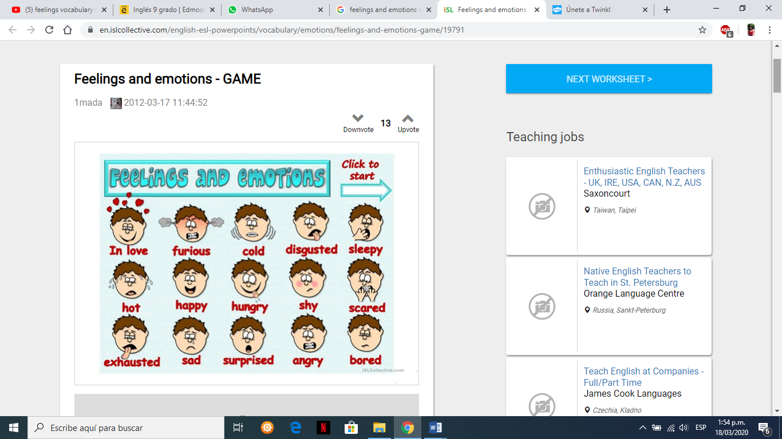

* Watch the video.

<https://www.youtube.com/watch?v=yhq1wuu7NFk>, take notes and review the verb to be in present and then remenber the forms of verb to be in past.

* Copy the examples in the notebook.
* Watch the video.

<https://www.youtube.com/results?search_query=ingl%C3%A9s+facil-Alema> , take the notes in your copybook about conjugation of the verb to be in past tense and the given examples.

* Practice the pronunciation by repeating it.
* Take notes in your copybook of the explanations and the given examples.

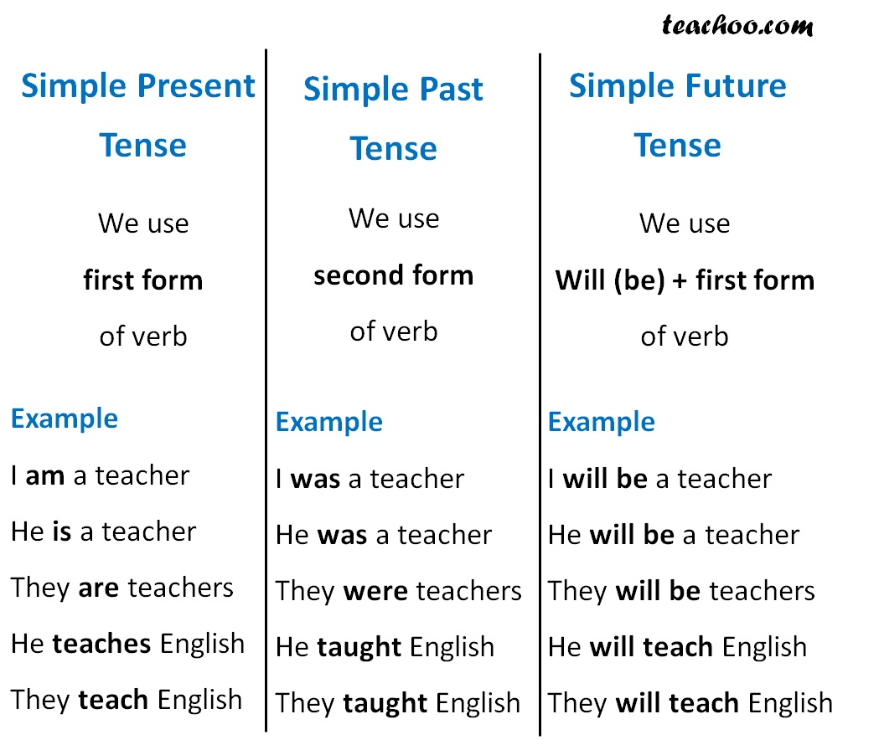

* **APPLICATION EXAMPLES:**

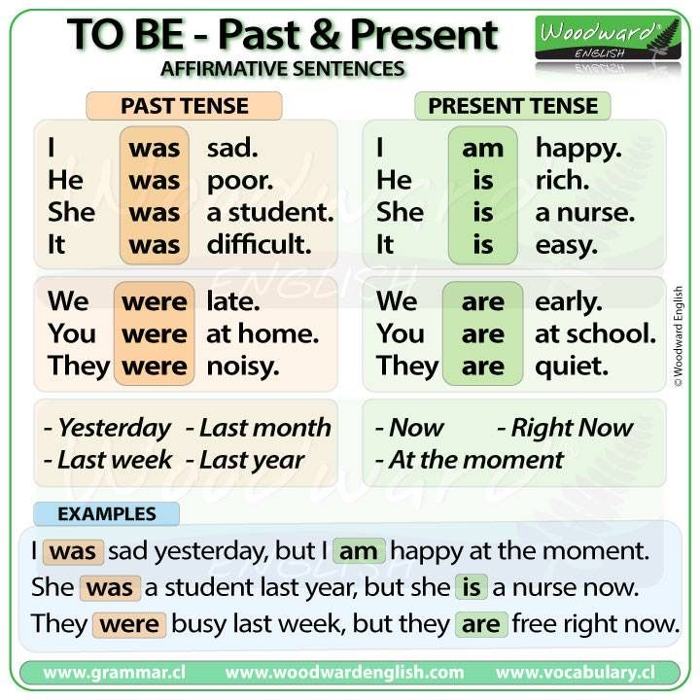

* Read the examples and using the information, write your own examples in the copybook.
* Select an example and write it in negative and interrogative forms with the answers.

**IN THE FUTURE:**

You ***will be*** happy.

She***’ll be*** a student.

They ***won’t be*** busy next week.

Will you be sleepy in class?

***Time expressions:*** tomorrow, next day, next week, later, next year.

* Read the above information about the future and then, do 5 sentences in affirmative, negative and interrogative forms with answers by using the vocabulary and the all explanations.
* Write the sentences in your copybook.
* **EVALUATION:**
* Write the sentences according to the clues pronoun, the verbal tense and the form of the sentence. Use the copybook.

1. Past, negative: they/sad
2. Present, interrogative: she/ hungry
3. Future, positive; we/ happy
4. Past ,interrogative WH question: I/ sick
5. Present, negative: you/scared