INSTITUCIÓN EDUCATIVA COLEGIO PROVINCIAL SAN JOSÉ

SEDE PRINCIPAL

TALLER DE INGLÉS

PAST SIMPLE

**PAST TENSE**

**Tema:** Past sentence con **verbos regulares**

Para el inicio de este taller deberá tener en cuenta los siguientes pasos.

1. Instrucción (Cuándo usar pasado simple)
2. Ver un vídeo (Explicación del tema pasado simple)
3. Ejemplos (afirmativo, negativo, interrogativo)
4. Ejercicios para reforzar el tema previamente visto

**Let’s start!**

1. **Instrucción, Cuándo usar pasado simple**

## **¿Cómo utilizamos este tiempo verbal?**

El Past SIMPLE es usado para referimos a las acciones completas en el pasado.

Es decir, acciones que finalizaron en un tiempo determinado.

Los verbos regulares son aquellos verbos que no presentan modificaciones en sus conjugaciones, se caracterizan por finalizar con “ed”.

**Ejemplo:**

**Want**: Wanted

**Play**: Played

**Achieve**: Achieved

|  |
| --- |
| * I wanted to dance. (*Yo quería bailar*) * They learned English. (*Ellos aprendieron Inglés*) |

1. **Ver vídeo sobre el uso de pasado simple (Explicación y estructura)**

<https://www.youtube.com/watch?v=3jWLMZrTzyQ>

**Ejemplo**

|  |
| --- |
| **Afirmativo:** I learned English eight years ago  **Negativo:** I did not learn English eight years ago  **Interrogativo:** Did I learn English eight years ago?  **Answer :** Yes, I did / No, I did not |

**Estructura**

**Afirmativo**

|  |
| --- |
| Pronouns + Past of verb to be + complement  You danced at the disco, yesterday. |

**Negativo**

|  |
| --- |
| Pronouns + did not + Present of regular verbs + complement  You did not dance at the disco, yesterday. |

**Interrogativo**

|  |
| --- |
| Auxiliar + Pronoun + verb (present) + complement ?  Did you dance at the disco, yesterday? |

**Para el pasado del verbo to be se tendrá en cuenta lo siguiente:**

|  |  |
| --- | --- |
| YOU  THEY  WE | WERE  WERE NOT  WERE YOU …..? |

|  |  |
| --- | --- |
| I  SHE  HE  IT | WAS  WAS NOT  WAS I ...? |

**Ejemplos**

**Afirmativo: Was / were**

|  |
| --- |
| * I was in Bucaramanga yesterday. Yo estuve en Bucaramanga ayer. * You were in Bucaramanga yesterday * She was in Bucaramanga yesterday * He was in Bucaramanga yesterday * It was in Bucaramanga yesterday * They were in Bucaramanga yesterday. * We were in Bucaramanga yesterday |

**Negativo:**

forma corta: Wasn’t / weren’t

Forma larga: Was not / were not

|  |  |
| --- | --- |
| Forma Larga | Forma corta |
| * I was not in Bucaramanga yesterday * You were not in Bucaramanga yesterday | * I wasn’t in Bucaramanga yesterday * You weren’t in Bucaramanga yesterday |

**Interrogativo:**

Were we in Bucaramanga yesterday? ¿Estuvimos nosotros en Bucaramanga ayer?

Yes, we were

No, we were not

**Material de apoyo**

Es necesario revisar estos links con el fin de familiarizarse con las reglas que los verbos regulares presenta.

<https://www.spanishdict.com/guia/los-verbos-regulares-en-el-pasado>

1. **Ejercicio**
2. **Estudiar y memorizar el listado de verbos regulares en Inglés principalmente el infinitivo y el pasado simple y su respectivo significado.**

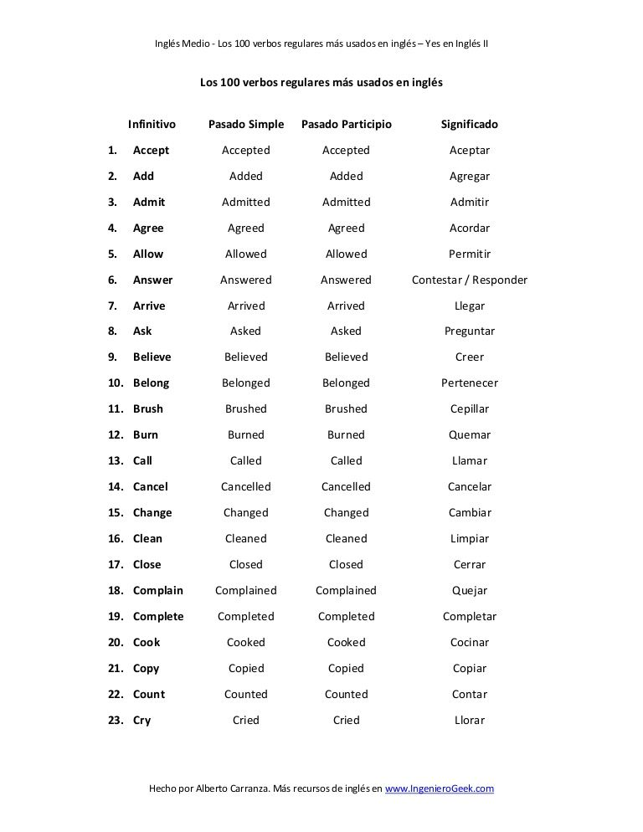

**2. Complete the sentences with the verbs in parenthesis. Use the past simple.**

a. You arrived (arrive) to England last week.score

b. My mum _______________(study) Russian at university.score

c. I ______________(phone) you yesterday, but you weren't at home.score

d. Last night, Marga and Alice ___________(plan) their holiday.score

e. Tom ________________( invite) us to his birthday party.score

f. The children _____________ (carry) the books to the classroom.score

g. We ____________(finish) the exam at half past three.score

h. I ______________(chat) to Jane about films and fashion.

1. **Tranforme cada una de las oraciones del punto anterior en la forma negativa agregando “did not”**

**a. You did not arrive to England last week.**

**b._________________________________________**

**c. __________________________________________**

**d. __________________________________________**

**e. __________________________________________**

**f. ___________________________________________**

**g. ___________________________________________**

**h. ____________________________________________**