|  |  |
| --- | --- |
| **ÁREA** | FOREIGN LANGUAGES |
| **SUBJECT** | ENGLISH |
| **UNIT** | WORK, REST AND PLAY |
| **GRADE** | EIGHTTH 04,05,06 |
| **TEACHER** | MARTHA ELENA GUERRERO RAMÓN |

**BASIC LEARNING RIGHTS (DBA):**

* Talk about a typical day
* Talk about free time.
* Describe a special celebration or festival.
* Describe daily life in different communities.

**COMPETENCES:**

* Talk about typical day.
* Talk about free time.
* Describe a special celebration or festival.
* Describe daily life in different communities.

**STUDY TIME :** Four Hours

**GENERAL INSTRUCTIONS:**

This workshop is designed so that students can develop it at home using their books, notebooks and if possible, the use of Internet as a tool for their development.

* The main objective is to strengthen the knowledge acquired in class to continue with a new subject.
* This work is divided in grammar review, grammar and vocabulary, reading comprehension, writing practice, games and assessment to verify the scope of achievement in this unit.

**PREVIOUS KNOWLEDGE**

* Concepts about: Daily Activities
* Vocabulary about Party words.
* Describe Celebrations and Festivals around the world.
* Describe positive and negative parts of occupations.

**PRESENTATION OF NEW KNOWLEDGE**

* Use the Present Simple Tense
* Prepositions of Time.
* Adverbs of Frequency.
* Vocabulary from the unit.

**WORKSHOP: “SIMPLE PRESENT TENSE”**

* **PRESENTATION OF THEME : “ SIMPLE PRESENT TENSE ” .**

1. **GRAMMAR EXPLANATION.**

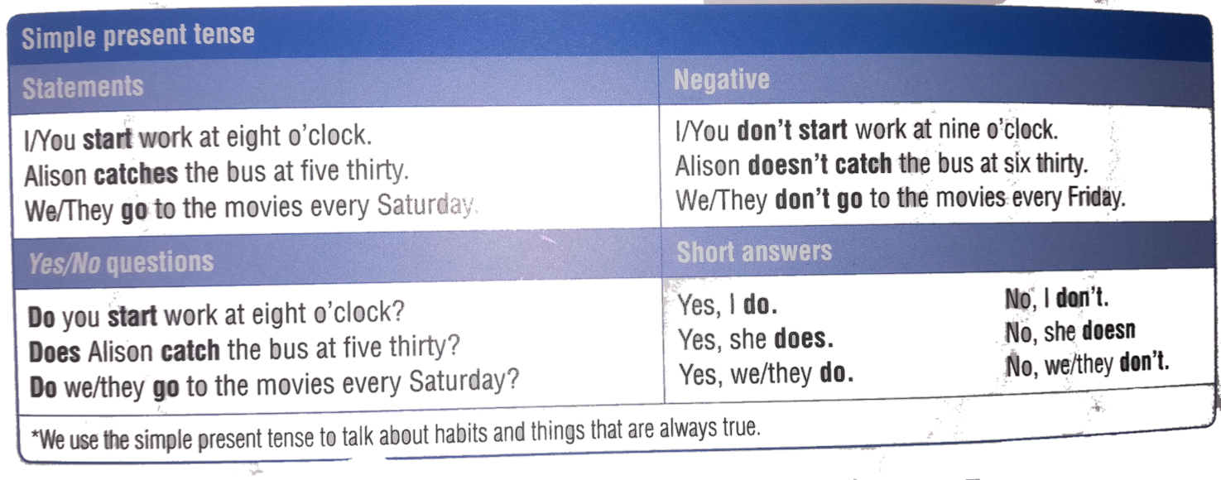

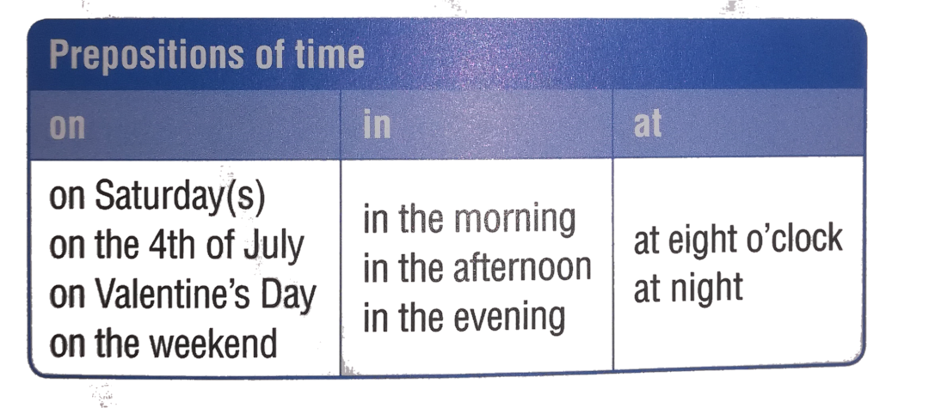

**EXAMPLES:**

**AFIRMATIVE FORM.**

1-Mati is a hairdresser.He **cuts** hair

2- Sharon is a waitress. She **serves** food.

3- Carol is a chef. She **cooks** delicious.

4- Hector is an architect. He **designs** buildings.

5-Carl is firefighter. He **puts** out fires.

**NEGATIVE FORM.**

1. I **don’t go** to school on Sundays.
2. You **don’t play** basketball with your friends.
3. He **doesn’t study** English today.
4. She **doesn’t make** home works very well.
5. They **don’t understand** this lesson.

**INTERROGATIVE FORM**

1. **Do you** travel to Bogotá this month?
2. **Do we** think to prepare a party next month?
3. **Does he** writethe reading in a correct way**?**
4. **Do they** know how to do this work?
5. **Does she** understand the math exercise?

.

**B- CHANGE THIS SENTENCES TO THE THIRD PERSON (PRESENT SIMPLE -AFFIRMATIVE) USING HE / SHE.**

1. I go to work every day**. He goes** to work every day.
2. We study English at school**. He studies** English at school.
3. They speak Spanish very well. ____________________________.
4. I have many friends at school. ___________________________.
5. You deliver pizza on Sundays. ___________________________.
6. I read this magazine for my children. _______________________.
7. They write to you many letters. ____________________________.

**C- ANSWER THESE QUESTIONS USING: Yes, I do / No, I don’t / Yes, I am / Not, I’m not / Yes, It is / No, it isn’t. Underline all the prepositions of time.**

1. Do you have vacations on July? ______________________________.
2. Are you busy on Wednesday? _______________________________.
3. Do you have breakfast in the morning? _________________________.
4. Do you have lunch at noon? _________________________________.
5. Are you with your family at Easter?____________________________.
6. Do you meet your friends at dinner ?___________________________.
7. Do you study in the afternoon ?_______________________________.
8. Do you play soccer on Sunday? ______________________________.

**D- COMPLETE WITH THE CORRECT PREPOSITIONS : AT, ON, IN.**

1. We work __________ Mondays.
2. Jenna teaches __________ the afternoons.
3. My friend arrives __________ January.
4. My birthday is _________ Spring.
5. Tom comes home _________ 7 o’clock.
6. Victoria has lessons _________ every day.
7. I sleep ________ the sommier.
8. This office is closed ___________ Friday.
9. I have vacations _________ Summer.
10. We have breakfast _________ morning.

**E- VOCABULARY PRACTICE WITH IMAGES.**

**Label the pictures using phrases from the box.**

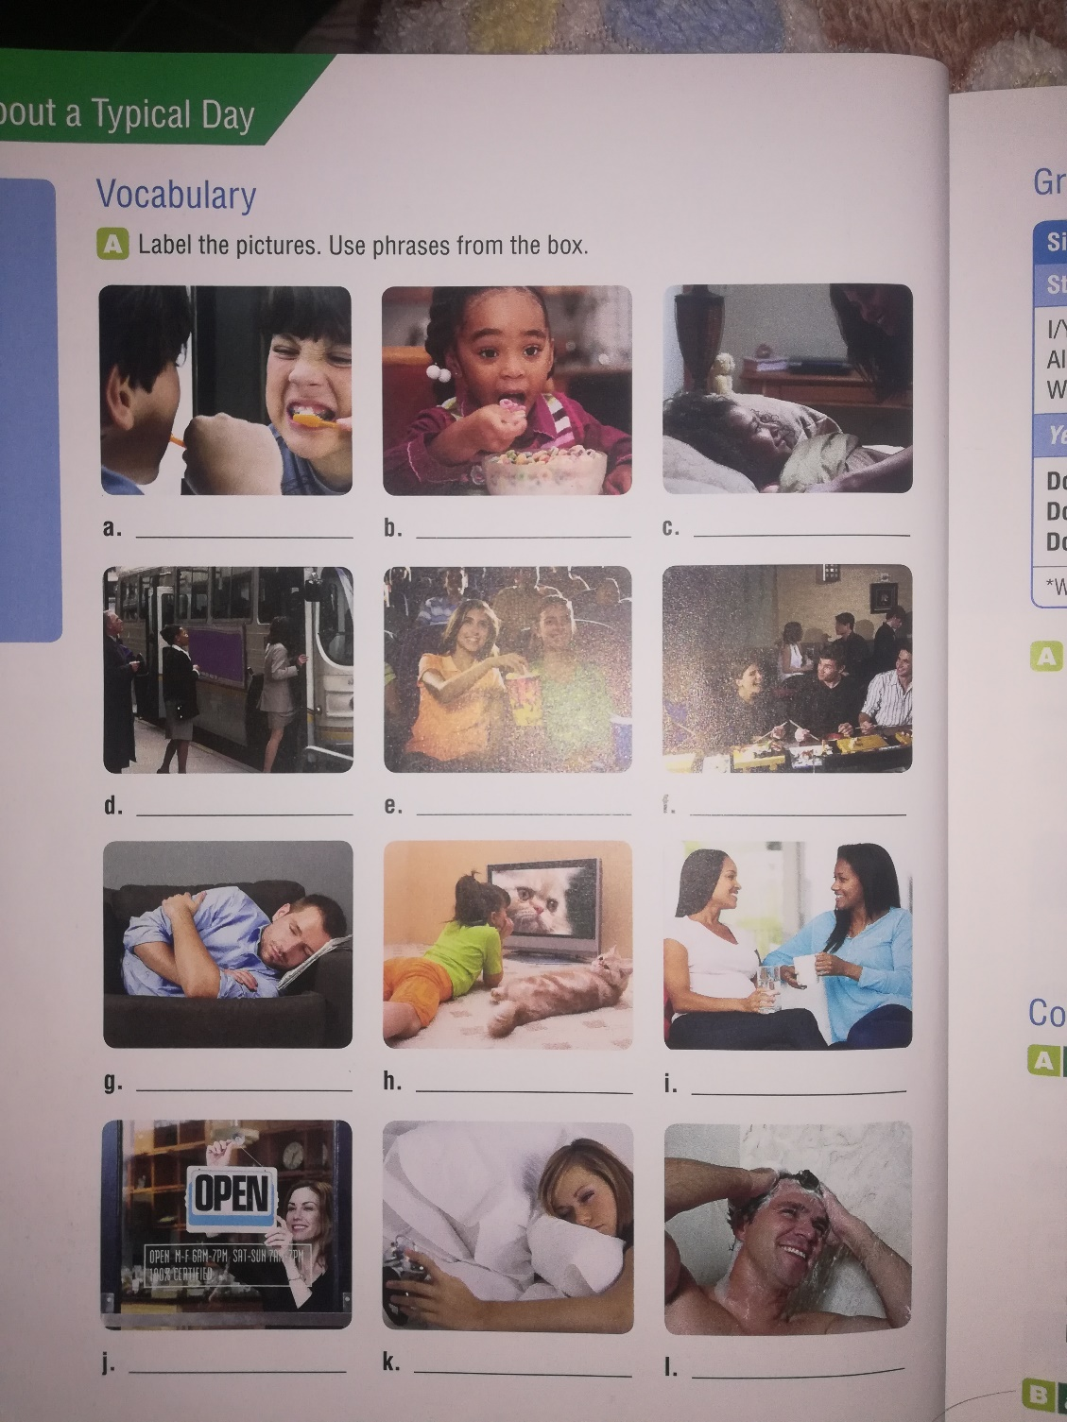

* Brush your teeth
* Get up
* Eat breakfast
* Go to bed
* Take a shower
* Catch the bus
* Go to the movies
* Take a nap
* Watch TV
* Visit Friends
* Start Work
* Eat out

**F- READING COMPREHENSION.**

**“ A VIRTUAL CHOIR 2.000 VOICES STRONG “**

Erick Whitacre is a **composer** and **conductor.** He is excited about using **choral** music to join people together from all around the world.

As a child, Eric Whitacre lived in a small town with many farms. He loved music. He didn’t know how to read music but he often played instruments. He always wanted to be part of the rock or pop band. Years later, he went to college. There he met the conductor of the college **choir.** At first**,** Eric didn´t want to join the choir, but finally he did.

The first time that Eric Whitacre sang with the choir, it was a big surprise. He thought that choral music was beautiful and interesting. He learned how to read music, and then he began to write musical pieces. He became a successful composer and conductor.

Whitacre’s choir is very unusual because it´s completely **virtual.** The internetmakes this possible.

The members of the choir don´t know each others. They are different ages, from different countries, and have different professions. But they are united by their love of singing and their desire to be part of a worldwide community that makes beautiful music.

**Read the article and choose the correct answers.**

1. **As a child , Eric Whitacre wanted to be:**

. a- A teacher b- A composer c- In a band d- Any one of these.

1. When Eric Whitacre ___________ for the first time, it surprised him.
2. Wrote music b-Sang with a choir c- Met a conductor d- All of these.
3. He became a famous conductor and ______________.
4. Composer b- Singer c- Student d- Doctor.
5. _____________ Makes it possible for people all over the world to join Eric

Whitacre’s virtual choir.

1. Pop music b- College c- The Internet d- All of these.
2. The people in the choir are united by _____________.
3. A love of singing b- Living near each over c- Family d- All of these.

**READING:**

**“PEOPLE AROUND THE WORLD “**

Today, many people go to work in new countries. Here, we’ll learn about four people and their jobs.

Michael Murphy is a doctor. He’s from Ireland, but he works in many countries. He says, “My work is sometimes dangerous, but it’s always interesting. It’s a difficult job, but I love helping people.”

Natsuko Mori is from Osaka, Japan, England. She works in Brazil now. She says “I’m a teacher in a language school. I teach Japanese to Brazilian students. My students are very good, and I like my job”

Shaukat Ali is a taxi driver in London, England. He’s from Pakistan. He says, “I love my job! It’s difficult because London is so big. But the people are very nice. I love talking to people from different countries, so it’s an interesting job”

Moises Agba is a soccer player from Nigeria, in Africa. Now he plays for a team in Italy. He says, “People think my job is exciting. That’s true, but it isn’t easy. I like living in Italy, and I love playing soccer, so I’m really happy person”

**Read the sentences.** Circle **T** for *true* or **F** for *false*

1. Natsuko is Brazilian **T F ______________________**
2. Shaukat works in a car **T F ______________________**
3. Playing soccer is an easy job **T F ______________________**
4. Michael’s job is dangerous **T F ______________________**
5. Shaukat’s and Michael’s job are **T F ______________________**

Boring

1. Teaching Japanese is a difficult job. **T F ______________________**
2. Moses isn’t happy. **T F ______________________**
3. These people like their jobs **T F ______________________**

**MATERIAL DE APOYO ONLINE**

1. <https://www.perfect-english-grammar.com/present-continuous.html>
2. <https://www.perfect-english-grammar.com/present-continuous-use.html>
3. <https://www.perfect-english-grammar.com/present-simple-or-present-continuous.html>
4. <https://www.perfect-english-grammar.com/modal-verbs-of-ability.html>

**EJERCICIOS DE REFUERZO ONLINE**

1. <https://www.perfect-english-grammar.com/modal-verbs-of-ability-exercise-1.html>
2. <https://www.perfect-english-grammar.com/present-simple-present-continuous-1.html>
3. https://www.letshavewithenglish.com/games/possessiveadjectives/.