|  |  |
| --- | --- |
| **ÁREA** | FOREIGN LANGUAGES |
| **SUBJECT** | ENGLISH |
| **UNIT** | PEOPLE |
| **GRADE** | EIGHTTH 04,05,06 |
| **TEACHER** | MARTHA ELENA GUERRERO RAMÓN |

**BASIC LEARNING RIGHTS (DBA):**

* Briefly narrates current facts, daily situations or personal experiences orally and in written way.
* Recognizes specific information about jobs and occupations describing positive and negative parts from them.
* Writing about people’s occupations and nationalities.

**COMPETENCES:**

* Meet People asking and giving personal information.
* Be able to describe different occupations,
* Talk and describe different occupations.

**STUDY TIME :** Four Hours

**GENERAL INSTRUCTIONS:**

This workshop is designed so that students can develop it at home using their books, notebooks and if possible, the use of Internet as a tool for their development.

* The main objective is to strengthen the knowledge acquired in class to continue with a new subject.
* This work is divided in grammar review, grammar and vocabulary, reading comprehension, writing practice, games and assessment to verify the scope of achievement in this unit.

**PREVIOUS KNOWLEDGE**

* Concepts about: Meeting People and identify activities that are happening now.
* Ask and give personal information.
* Describe different occupations and talk about them.
* Describe positive and negative parts of occupations.

**PRESENTATION OF NEW KNOWLEDGE**

* Use the Present Progressive Tense in short conversations or readings.
* Possessive Adjectives.
* Grammar: Be +Adjective ( +Noun ).
* Vocabulary from the unit.

**WORKSHOP: “PEOPLE”**

* **GRAMMAR AND VOCABULARY:**

1. **UNSCRAMBLE THE JOB TITTLES. COMPLETE THE SENTENCES.**

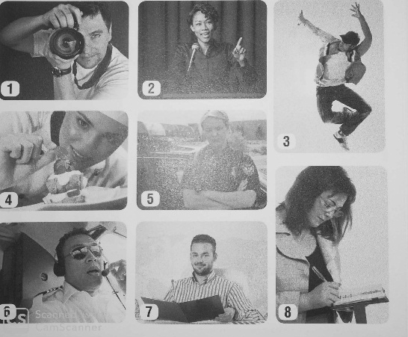 **Example:**

1. (hpootragephr) He’s a photographer.
2. (nolitpcaii) She’s a ____________________.
3. (cnadre) He’s a _______________________.
4. (fche) She’s a _________________.
5. (icelop fofcire) She’s a _________________.
6. (tolpi) He’s a _______________.
7. (lervta getna) He’s a ____________________.
8. (anjtiulros ) She’s a _____________________.

1. **WRITE THE NATIONALITY.**

1.France____________________ 2. Australia__________________.

3.Jordan __________________ 4. Peru _____________________.

5.Ireland____________________ 6. Mexico____________________.

7.Japan_____________________ 8. Your Nationality____________.

1. 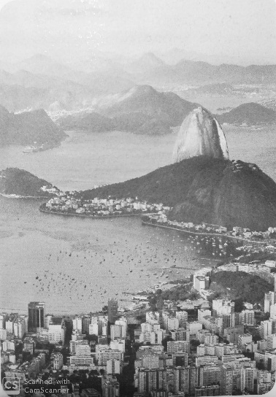**Read the conversations. Write the pronouns and the correct form of Be.**

* **Cristina:** Where (1) are you ________ from, Mike?
* **Mike:** (2) ______________________ from Australia.
* **Cristina:** So, (3) ______________________Australian. Sounds cool. (4) __________________________ from Sidney?
* **Mike:** Yes, I am. And you, Cristina? (5)___________________ Mexican?
* **Cristina:** No, (6) ________________________. (7) ____________________ Brazilian.
* **Mike:** Wow! Brazil. I’d love to go to Brazil. Which city (8) _________________from?
* **Cristina**: No, (9)______________________from Rio de Janeiro. (10)_____________________________ a cool city.

1. **MATCH THE OPPOSITES.**
2. Good _________________ a. Easy.
3. Rich _________________ b. Bad.
4. Boring_________________ c. Safe.
5. Happy ________________ d. Poor.
6. Dangerous______________ e. Unhappy.
7. Difficult ________________ f. Interersting.
8. **COMPLETE THE SENTENCES WITH POSSESIVE ADJECTIVES ( MY, YOUR, HER, HIS, OUR, THEIR ).**
9. Hello! _________ name is Young – Min.
10. Ms. Costa is a photographer. _________ job is very interesting.
11. They’re my brothers. ___________names are Martin and Julio.
12. You’re a dancer! Is ___________ difficult job?
13. I like my teacher. _____________ name is Mr. Clark.
14. Mr. Shen likes ____________ Job. He’s an Engineer.
15. **COMPLETE THE SENTENCES ABOUT JOBS. USE YOUR IDEAS.**
16. Her Job is dangerous. She’s a pilot.
17. His Job is interesting. He’s ____________________.
18. Her Job is boring. She’s ______________________.
19. Our job is difficult. We’re ______________________.
20. Their Job is Easy. They’re _____________________.
21. **UNSCRAMBLE THE QUESTIONS. THEN WRITE YOUR ANSWERS.**
22. (your what name is )________________________________.
23. (from you are where )_______________________________.
24. (you what do do ) __________________________________.
25. (work is your interesting )___________________________.
26. (His isn’t notebook order )____________________________.

**H. WRITE THE PERSON’S NAME. YOU CAN REPEAT NAMES.**

**1**.________________________________is Japanese.

**2**.________________________________lives in Italy.

**3**.________________________________ work with students.

**4**.________________________________ has a dangerous job.

**5**.________________________________ works in a big city.

**6**.________________________________ is Irish.

**7**.________________________________ has an exciting job.

**8**.________________________________ loves talking to people.

1. **MATCH THE QUESTIONS AND ANSWERS.**
2. What are you reading?_____________________a) No, they aren’t.
3. Are they going for a walk? __________________ b) Yes, she is.
4. What is Brandon doing? ____________________ c) I’m going to my computer class.
5. Is Sara cooking lunch? _____________________d) I’m reading an interesting book.
6. Where are you going? _____________________e) He’s watching TV**.**
7. **MATCH THE TELEPHONE EXPESSIONS TO THE SITUATIONS.**
8. Can I leave a message? __________ a) You can’t hear the caller.
9. Could I call you back? ___________ b) You are busy and can’t talk.
10. Who is speaking please? ________ c) You don’t know the caller.
11. Sorry, could you speak up? _______ d) The person you are calling is not avaible.
12. **COMPLETE THE CONVERSATIONS. WRITE THE VERBS IN A CORRECT FORM.**
13. **A.** Hi! What are you doing? (you/do)?

**B**. _____________________ (I / go) to the movies with Ana. Come with us!

**A.** Ok. Thanks!

**2. A: Hi. How are you?**

**B:** Oh, hi. Can I call you back? _________________________ (I / Watch) TV.

**A:** Sure, call me on my phone. ______________________ (we / go) for a walk.

**A:** Hi, I’m at the supermarket. _______________________ (you/cooking)dinner?

**B:** Yes. ______________________ (you / Buy) rice, please.

**A:** Ok. Bye.

1. **WRITE THE FOLLOWING VERBS IN PRESENT AND PAST FORMS AND THEIR MEANING.**
2. TRADUCIR ____________________ .
3. VERIFICAR_____________________.
4. PERMANECER_____________________.
5. DESCANSAR______________________.
6. REVISAR_________________________.
7. TRABAJAR ________________________.
8. ESCUCHAR_______________________.
9. CAMINAR________________________.
10. CONVERSAR______________________.
11. COMENZAR______________________.
12. **READING AND WRITING**

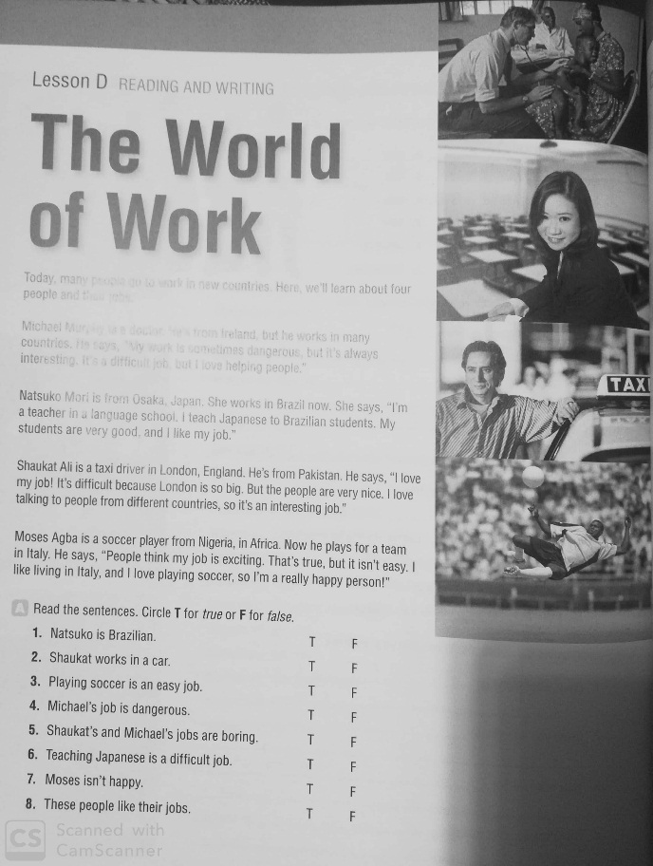

**THE WORLD OF THE WORK**

Today, many people go to work in new countries. Here, we’ll learn about four people and their jobs.

Michael Murphy is a doctor. He’s from Ireland, but he works in many countries. He says, “My work is sometimes dangerous, but it’s always interesting. It’s a difficult job, but I love helping people.”

Natsuko Mori is from Osaka, Japan, England. She works in Brazil now. She says “I’m a teacher in a language school. I teach Japanese to Brazilian students. My students are very good, and I like my job”

Shaukat Ali is a taxi driver in London, England. He’s from Pakistan. He says, “I love my job! It’s difficult because London is so big. But the people are very nice. I love talking to people from different countries, so it’s an interesting job”

Moises Agba is a soccer player from Nigeria, in Africa. Now he plays for a team in Italy. He says, “People think my job is exciting. That’s true, but it isn’t easy. I like living in Italy, and I love playing soccer, so I’m really happy person”

**Read the sentences.** Circle **T** for *true* or **F** for *false*

1. Natsuko is Brazilian **T F ______________________**
2. Shaukat works in a car **T F ______________________**
3. Playing soccer is an easy job **T F ______________________**
4. Michael’s job is dangerous **T F ______________________**
5. Shaukat’s and Michael’s job are **T F ______________________**

Boring

1. Teaching Japanese is a difficult job. **T F ______________________**
2. Moses isn’t happy. **T F ______________________**
3. These people like their jobs **T F ______________________**
4. **Solve the crossword puzzle with vocabulary and grammar from this unit.**

* 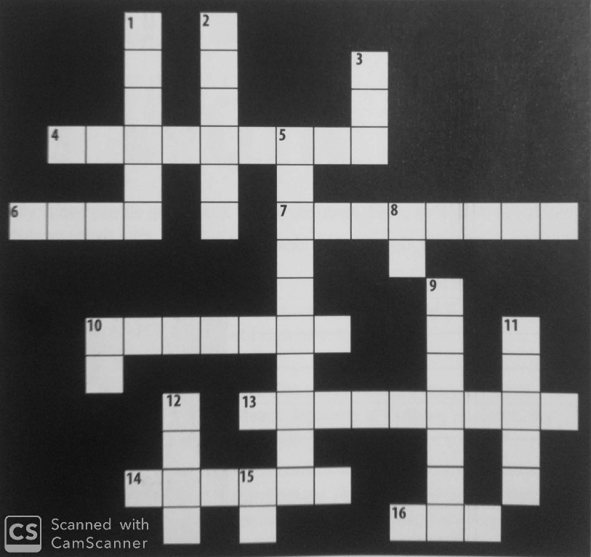**ACROSS**

**4-** not safe

**6-** not poor

**7-** He’s from Canada. He’s _____.

**10-** I’m from Mexico. I’m _______.

**13.** not easy

**14-** not interesting

**16-** They _____students

**DOWN**

**1-**She’s from France. She’s ________.

**2-** They’re from Korea. They’re _______.

**3-** I have a brother. _______ name is Hiroshi.

**5-** job

**8-** I_________ a journalist.

**9-** A ____________ works in a school.

**10-** I like _________job because it’s exciting

**11-** A __________ works in an airplane.

**12-** I’m _________Colombia.

**15-** My name __________ Elisa

**Ñ) Write about you and your job or about somebody you know and his or her job. Use words from the unit.**

________________________________________________________________________________________________________________________________________________________________________________________________________________________________________________________________________________________________

**MATERIAL DE APOYO ONLINE**

1. <https://www.perfect-english-grammar.com/present-continuous.html>
2. <https://www.perfect-english-grammar.com/present-continuous-use.html>
3. <https://www.perfect-english-grammar.com/present-simple-or-present-continuous.html>
4. <https://www.perfect-english-grammar.com/modal-verbs-of-ability.html>

**EJERCICIOS DE REFUERZO ONLINE**

1. <https://www.perfect-english-grammar.com/modal-verbs-of-ability-exercise-1.html>
2. <https://www.perfect-english-grammar.com/present-simple-present-continuous-1.html>