|  |  |
| --- | --- |
| **ÁREA** | FOREIGN LANGUAGES |
| **SUBJECT** | ENGLISH |
| **UNIT** | FREE TIME |
| **GRADE** | SEVENTH 04, 05,06 |
| **TEACHER** | MARTHA ELENA GUERRERO RAMÓN |

**BASIC LEARNING RIGHTS (DBA):**

* Expresses emotions and feelings about a situation or specific topic related to his / her family or school and present supporting reason in clear or simple manner.
* Recognizes specific information in written and oral texts related to objects, people, jobs and actions.

**COMPETENCES:**

* **STUDY TIME:** Four Hours.

**GENERAL INSTRUCTIONS:**

* This workshop is designed so that students can develop it at home using their books, notebooks and if possible, the use of Internet as a tool for their development.
* The main objective is to strengthen the knowledge acquired in class to continue with a new subject.
* This work is divided in grammar review, grammar and vocabulary, reading comprehension, writing practice, games and assessment to verify the scope of achievement in this unit.

**PREVIOUS KNOWLEDGE**

* Concepts about: Identify activities that are happening now.
* Make a phone call to talk about what a friend or family member is doing right now.
* Talk about abilities and sports.
* Use the most common Regular Verbs.

**PRESENTATION OF NEW KNOWLEDGE**

* Use the Present Progressive Tense in short conversations or readings.

**WORKSHOP: FREE TIME**

* **GRAMMAR AND VOCABULARY:**

1. 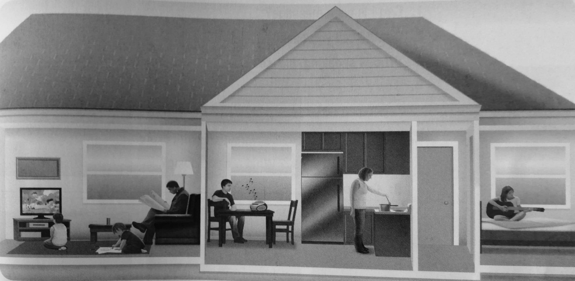 **LABEL THE ACTIVITIES:** look at the pictures to identify what activity they are doing.
2. **WRITE THE SENTENCES ABOUT SOME PEOPLE ARE DOING IN EXERCISE A**

**Example:**

1. He is watching T.V.
2. _____________________________________.
3. _____________________________________.
4. _____________________________________.
5. _____________________________________.
6. **MATCH THE QUESTIONS AND ANSWERS.**
7. What are you reading?_____________________a) No, they aren’t.
8. Are they going for a walk? __________________ b) Yes, she is.
9. What is Brandon doing? ____________________ c) I’m going to my computer class.
10. Is Sara cooking lunch? _____________________d) I’m reading an interesting book.
11. Where are you going? _____________________e) He’s watching TV**.**
12. **MATCH THE TELEPHONE EXPESSIONS TO THE SITUATIONS.**
13. Can I leave a message? __________ a) You can’t hear the caller.
14. Could I call you back? ___________ b) You are busy and can’t talk.
15. Who is speaking please? ________ c) You don’t know the caller.
16. Sorry, could you speak up? _______ d) The person you are calling is not avaible.
17. **COMPLETE THE CONVERSATIONS WITH THE EXPRESSIONS FROM EXERCISE A.**
18. **A**. Hi! How are you?

B. I’m cooking________________________________________?

**A.** Sure. I’m at home. Call me later.

**2. A.** Good Afternoon. Can I speak to Mr. Li, please?

**B. __________________________________________________.**

**A.** Guey Lan Wu.

**B**. I’m sorry, Mr. Li is not here.

**A. ___________________________________________________?**

**B.** Yes, of course**.**

1. **COMPLETE THE CONVERSATIONS. WRITE THE VERBS IN A CORRECT FORM.**
2. **A.** Hi! What are you doing? (you/do)?

**B**. _____________________ (I / go) to the movies with Ana. Come with us!

**A.** Ok. Thanks!

**2. A: Hi. How are you?**

**B:** Oh, hi. Can I call you back? _________________________ (I / Watch) TV.

**A:** Sure, call me on my phone. ______________________ (we / go) for a walk.

**A:** Hi, I’m at the supermarket. _______________________ (you/cooking) dinner?

**B:** Yes. ______________________ (you / Buy) rice, please.

**A:** Ok. Bye.

1. **VOCABULARY PRACTICE.**
2. **LABEL THE SPORTS.**

Ice skating

Biking

Volleyball

Swimming

Golf

Soccer

Tennis

Skiing

 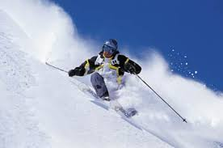

**1.___________________ 2.____________________** **3.**_________________________

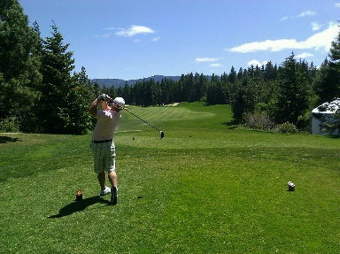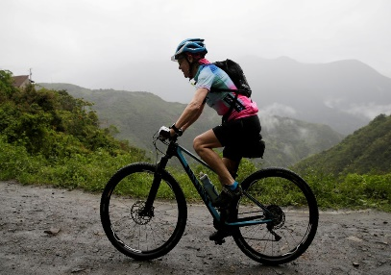

**4._____________________ 5.__________________________ 6.______________________**

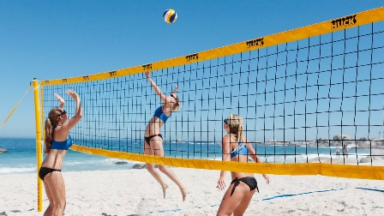

**7.______________________**

1. **Write sentences about these things in your notebook. Use can or can’t**

Ice skate

Play the guitar

Speak Spanish

Cook

Swim

1. **Complete the e-mail with can, can’t or can you.**

**Dear e-peal,**

Hi! It’s nice to meet you. My name is Laura Rios. I’m from Miami, Florida, In the United States.

I_______________ speak English and Spanish. We___________ write e-mails in Spanish if you like.

I love sports. I_____________ play tennis, golf, and soccer. ______________ play any sports?

I also like music. I _____________ play the guitar, but I ___________ sing because it’s too difficult.

I like food, but I ____________ cook very well. I can only make sandwiches. __________ cook?

*Please write me an e-mail!*

*Your friend,*

*Laura*

1. **Reading comprehension**

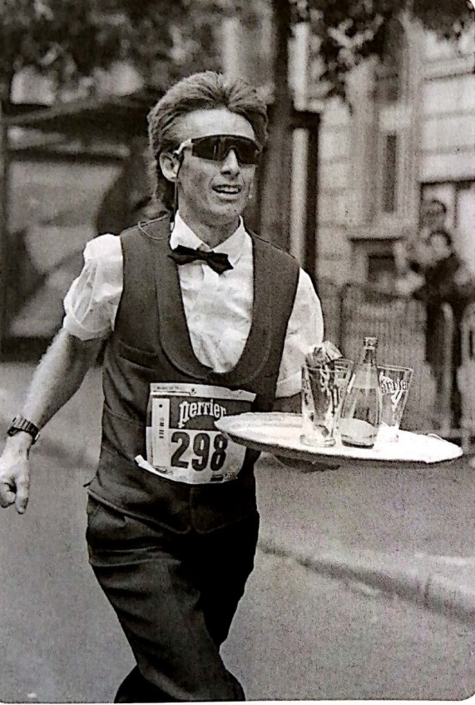This man works in a café. He is a waiter**.** Now he is an special race. He is walking and carrying tray of water!

Every year, in Paris, France, there is a race for café waiters. They walk 8 kilometers (5 miles) in the street of Paris. They carry a tray of drinks. The rules are simple: The waiters can’t run – they can only walk. They can’t drink the drinks. And they can’t drop their tray.

More than 500 people are in the race, and many other people watch the race.

Sometimes, waiters come from other countries to be in the Paris race. There also waiters’ races in different cities around the world, like Washington D.C, Sydney and London.

* Read the article. Circle **T** for *true* and **F** for *false.* Correct the sentences

1. The race is ~~England.~~  **T F**  France
2. The race is for café waiters **T F ______________________**
3. The waiters run in the race **T F ______________________**
4. The race is in the street **T F ______________________**
5. The race is 5 kilometers **T F ______________________**
6. There are more than 500 **T F ______________________**

people in the race

1. Waiters come from other **T F ______________________**

Countries for the race

1. There are now races in other **T F ______________________**

Countries

1. **Read the questionnaire. Write sentences about you and someone in your family or a friend.**

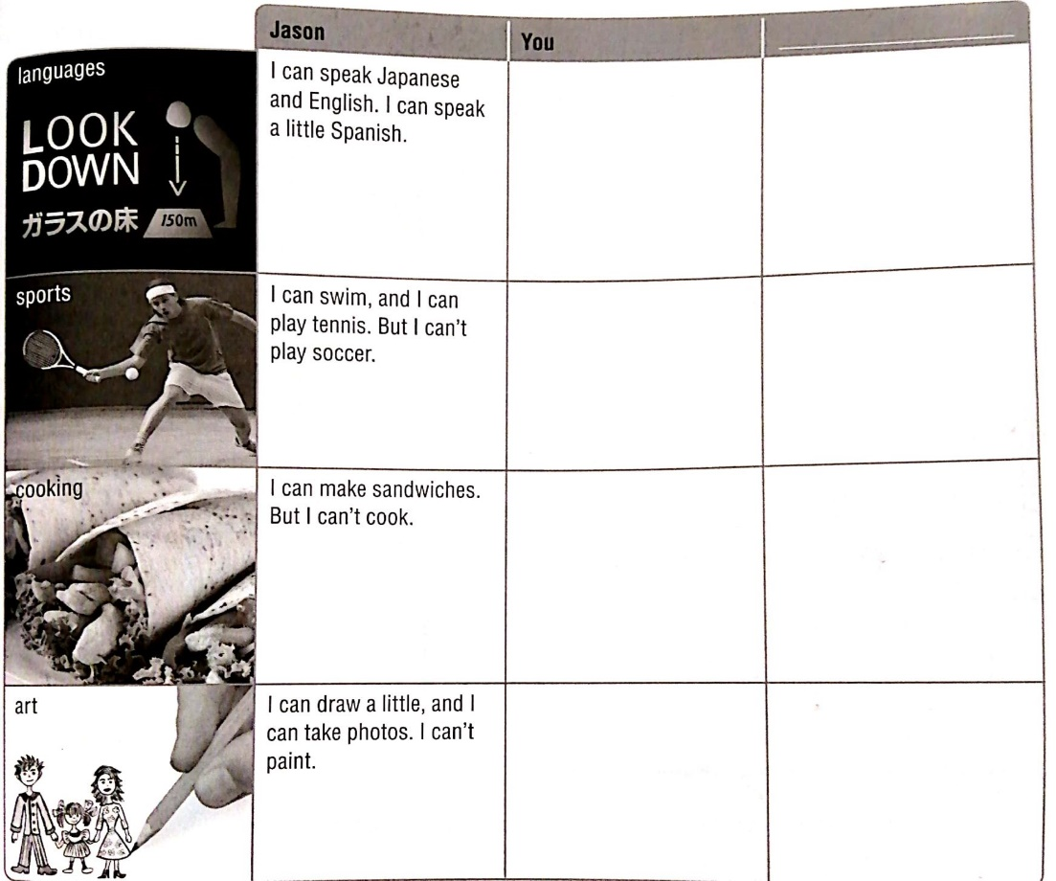

|  |  |  |
| --- | --- | --- |
| **JASON** | **YOU** |  |
| I can speak Japanese and English. I can speak a little Spanish. |  |  |
| I can swim, and I can play tennis. But I can’t play soccer. |  |  |
| I can make sandwiches. But I can’t cook. |  |  |
| I can draw a little, and I can take photos. I can’t paint. |  |  |

1. **Solve the crossword puzzle with vocabulary and grammar for this unit.**

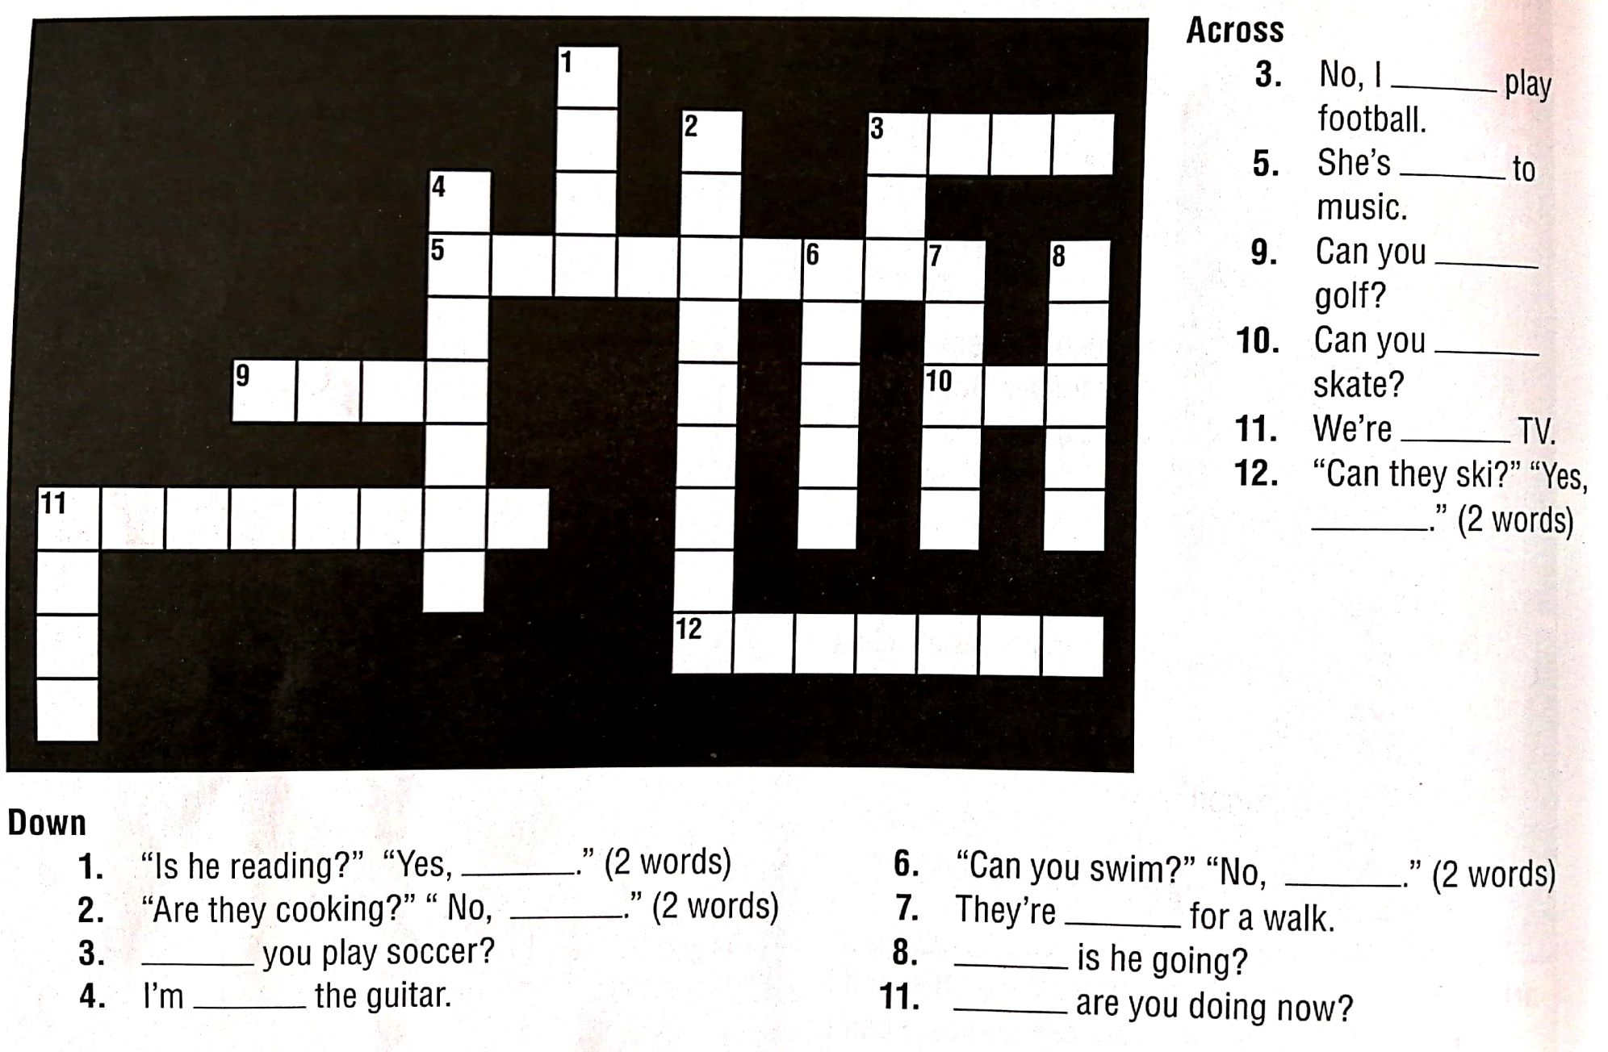

* **ACROSS:**

**3-** No, I __________ play football.

**5-** She’s _________ to music

**9-** Can you _______ golf?

**10-** Can you _______ skate?

**11-** We’re _________ TV?

**12-** “Can they ski?”____ Yes,_______ “ (two words)

**DOWN:**

1. “Is he reading?” “Yes, ________.” (2 words)
2. “Are they cooking?” “No, ________.” (2 words)
3. ________ you play soccer?
4. I’m ________ the guitar.

**6-** “Can you swim?” “No, __________.” (2 words)

**7-** They’re __________ for a walk.

**8- _________** is he going?

**11- ___________** are you doing now?

Studying, listening, can, ~~are,~~ can’t, can

1. **Complete the e-mail with words from the box**

Hey, Kris! How are you? What (1) are you doing? I’m (2) ___________________ and (3) _____________ to some really cool music. (4)________________ you play the guitar? I (5)_________________. ☹ . But I (6) _____________ sing 😊.

Call me later!

*Nuri*

1. **Write an e-mail to a friend about what are you doing now and what you can or can’t do. Use words from the unit.**

**MATERIAL DE APOYO ONLINE**

1. <https://www.perfect-english-grammar.com/present-continuous.html>
2. <https://www.perfect-english-grammar.com/present-continuous-use.html>
3. <https://www.perfect-english-grammar.com/present-simple-or-present-continuous.html>
4. <https://www.perfect-english-grammar.com/modal-verbs-of-ability.html>

**EJERCICIOS DE REFUERZO ONLINE**

1. <https://www.perfect-english-grammar.com/modal-verbs-of-ability-exercise-1.html>
2. <https://www.perfect-english-grammar.com/present-simple-present-continuous-1.html>