|  |  |
| --- | --- |
| **ÁREA** | FOREIGN LANGUAGES |
| **SUBJECT** | ENGLISH |
| **UNIT** | WHAT’S YOUR DAILY ROUTTINES |
| **GRADE** | SEXTING |
| **TEACHER** | MARTHA ELENA GUERRERO RAMÓN |

**BASIC LEARNING RIGHTS (DBA):**

* Expresses likes, preferences and personal daily activities using frequency
* structures.
* Expresses everyday actions that occur when speaking about temporary situations according to the situations and context.
* Information in relation to objects and actions.
* Reinforcement about use of Can and Can’t.

**COMPETENCES:**

* **STUDY TIME**: Four Hours.

**GENERAL INSTRUCTIONS:**

* This workshop is designed so that students can develop it at home using their books, notebooks and if possible, the use of Internet as a tool for their development.
* The main objective is to strengthen the knowledge acquired in class to continue with a new subject.
* This work is divided in grammar review, grammar and vocabulary, reading comprehension, writing practice , games and assessment to verify the scope of achievement in this unit.

**PRIOR KNOWLEDGE**

* concepts about: Identify activities that are happening now.
* Ask and give information about the hour.
* Give information about your daily routines at home and at school.

**PRESENTATION OF THE NEW KNOWLEDGE**

* Learn to describe yours and others’ Daily Routines using different Time Expressions.

**WORKSHOP: DAILY ROUTINES**

* **TIME TO START**

1. **CHECK THE ILLUSTRATIONS THAT REPRESENTS WHAT DO YOU DO EVERY DAY.**



1. **QUESTIONS – EXAMPLES.**

* What’s your daily routine like on weekdays? _____________________________.
* What´s your routine like on weekends? __________________________________.
* What´s your favorite day of the week and why? ____________________________.
* What time do you get up? ____________________________________.
* What time do you get breakfast? ____________________________.
* What time do you go to school? _________________________.
* What do you do after school? ___________________________.
* What time do you have lunch? _________________________.
* What time do you share with your family? ________________________.
* What time do you do homework’s? ______________________.
* What time do you go to bed? ________________________.
* What day of the week do you practice sports? ______________________.
* What day of the week do you rest at home? _____________________.

1. **MATCH THE TIMES ACCORDING TO THE IMAGES**

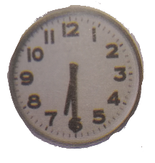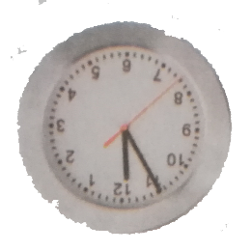

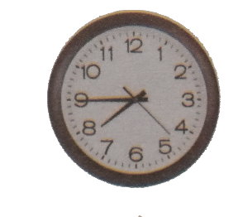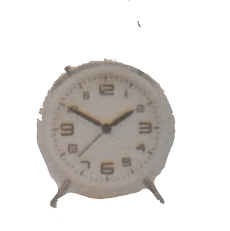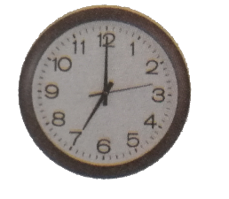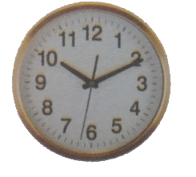

____________ ___________ ____________ __________ _________ ______

1. It’s seven o’clock
2. It’s half past six It’s half thirty.
3. It’s ten past ten.
4. It’s five to twelve. It’s eleven fifty-five.
5. It’s ten to two. It’s one fifty.
6. It’s a quarter to eight. It’s seven forty-five.
7. **STUDENTS’ PRACTICE: WHAT TIME IS NOW? DRAW, WRITE AND SAY IT.**

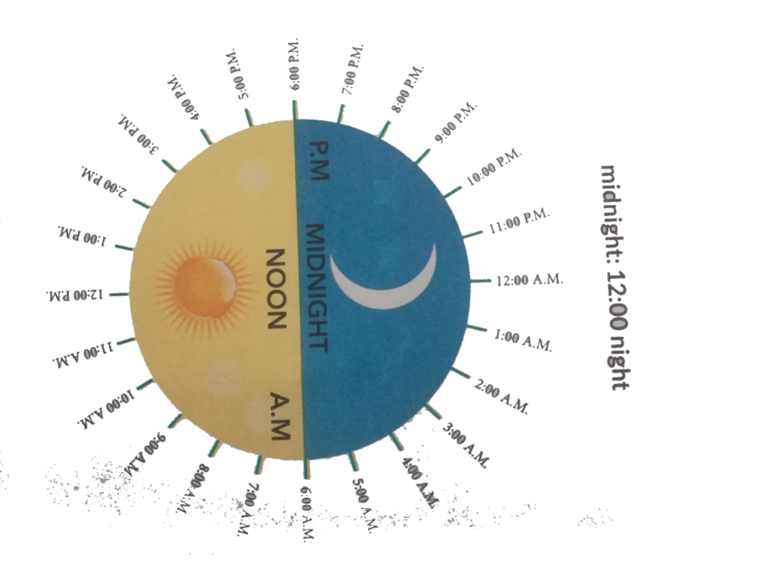

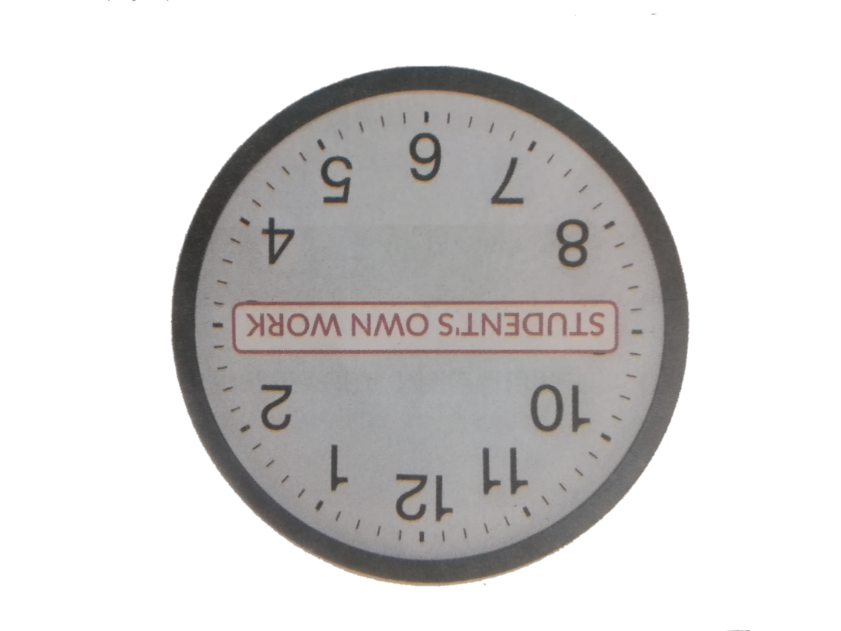

* **Students will translate to the English the following times and put them at the clock.**

1. Son las doce en punto.
2. Faltan diez minutos para las tres / Son las dos y cincuenta.
3. Son las siete y cuarenta y cinco / Falta un cuarto para las ocho.
4. Son las nueve y treinta y cinco / Faltan veinticinco para las ocho.
5. Son las cinco y cuarenta / Faltan veinte para las seis.
6. Son las seis y cincuenta y cinco / Faltan cinco para las siete.
7. **REVIEW: DAYS OF THE WEEK AND TIME EXPRESSIONS.**

* **Sunday - In the Morning**
* **Monday - In the Afternoon**
* **Tuesday - In the Evening**
* **Wednesday - At Night**
* **Thursday - At Midnight**
* **Friday -At Noon.**
* **Saturday**
* **Sunday.**

1. **LISTENING AND SPEAKING PRACTICE.**
2. Listen the order words and the teacher instruction and repeat the Days of the Week and the Time Expressions.
3. Start the lesson by asking to the students**: What time is it ?**
4. Draw five simple pictures similar to these on the board and tell students about your daily routine.

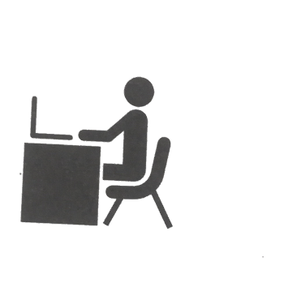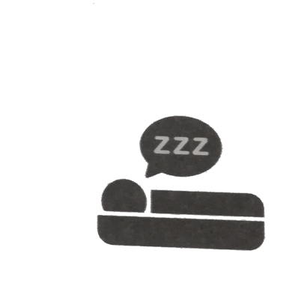

-I wake up at seven o’clock.

-I have breakfast at eight o’clock.

-I go to work at eight thirty.

-I watch tv at four in the afternoon.

-I go to sleep at ten o’clock.

-I go to sleep at noon.

1. **SPEAK UP – ORAL PRACTICE**

Ask students about their father or mother’s daily routine using these questions.

1. What time does he /she wake up?
2. What does he / she have breakfast?
3. What time does he /she go to work?
4. What time does he / she have lunch?
5. What time does he / she leave to work?
6. What time does he / she go to sleep?
7. **PROJECT @ HAND.**

Ask students to answer these questions for the article from the **Web Page** they’ve already visited.

1. Do successful people wake up early?
2. Is exercise an important part in the daily routine of successful people?
3. Do successful people work all the time?
4. Is personal time important?
5. Is the daily routine of successful people difficult to master?
6. Do successful people balance their time?

**SPEAK UP**

1. **COMPARE THE ILLUSTRATIONS, BRAINSTORM AND DISCUSS. INTERVIEW AND FIND THREE CLASSMATES WITH SIMILAR RUTINES.**

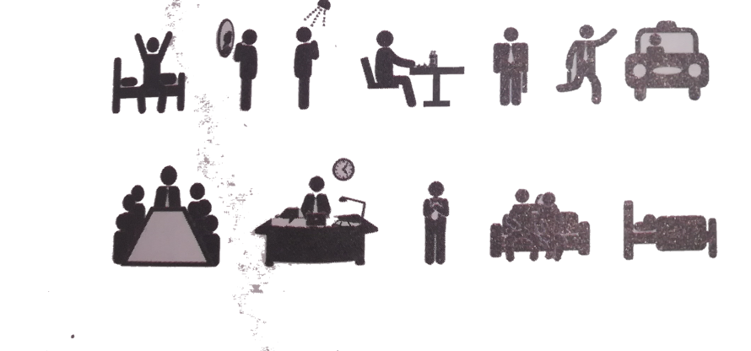

**IDENTIFY**

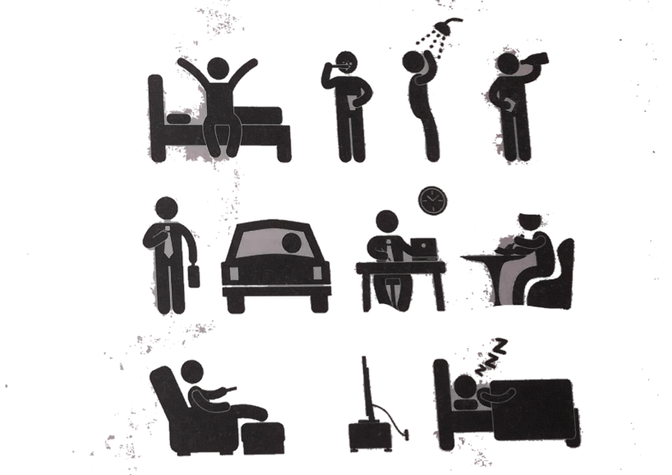

1. **WRITE THE SENTENCES ABOUT SOME PEOPLE ARE DOING IN EXERCISE A**

Example:

1. He is watching T.V.
2. _____________________________________.
3. _____________________________________.
4. _____________________________________.
5. _____________________________________.
6. **MATCH THE QUESTIONS AND ANSWERS.**
7. What are you reading? _______________________ a. No, they aren’t.
8. Are they going for a walk? _____________________ b. Yes, she is.
9. What is Brandon doing? ________________ c. I’m going to my computer class.
10. Is Sara cooking lunch? ________________________ d- I’m reading an interesting book.
11. Where are you going? ________________________ e. He’s watching.
12. **MATCH THE TELEPHONE EXPESSIONS TO THE SITUATIONS.**
13. Can I leave a message? __________ a-You can’t hear the caller.
14. Could I call you back? ___________ b-You are busy and can’t talk.
15. Who is speaking please? ________ c- You don’t know the caller.
16. Sorry, could you speak up? _______ d- The person you are calling is not avaible.
17. **COMPLETE THE CONVERSATIONS WITH THE EXPRESSIONS FROM**

**EXERCISE A.**

1. **A**. Hi! How are you?

**B**. I’m cooking________________________________________?

**A**. Sure. I’m at home. Call me later.

**2. A.** Good Afternoon. Can I speak to Mr. Li, please?

**B.** __________________________________________________.

**A.** Guey Lan Wu.

**B.** I’m sorry, Mr. Li is not here.

**A**. ___________________________________________________?

**B.** Yes, of course.

1. **COMPLETE THE CONVERSATIONS. WRITE THE VERBS IN A CORRECT FORM.**
2. **A.** Hi! What are you doing? (you /do)?

**B**. _____________________(I / go ) to the movies with Ana. Come with us!

**A.** Ok. Thanks!

**2. A.** Hi. How are you?

**B:** Oh, hi. Can I call you back? _____________________ (I / Watch ) TV.

**A:** Sure, call me on my phone. _____________________ (we / go) for a walk.

**A**: Hi, I’m at the supermarket. ______________________ (you /cooking) dinner?

**B:** Yes. ______________________ (you / Buy ) rice, please.

**A:** Ok. Bye.

**MATERIAL DE APOYO ONLINE**

1. <https://www.perfect-english-grammar.com/present-continuous.html>
2. <https://www.perfect-english-grammar.com/present-continuous-use.html>
3. <https://www.perfect-english-grammar.com/present-simple-or-present-continuous.html>
4. <https://www.perfect-english-grammar.com/modal-verbs-of-ability.html>

**EJERCICIOS DE REFUERZO ONLINE**

1. <https://www.perfect-english-grammar.com/modal-verbs-of-ability-exercise-1.html>
2. <https://www.perfect-english-grammar.com/present-simple-present-continuous-1.html>
3. https://www.letshavewithenglish.com/games/possessiveadjectives/.